**Feature Detection Algorithms:**

Original Image:

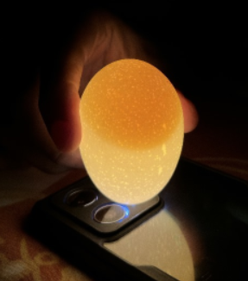

Grayscale Image:

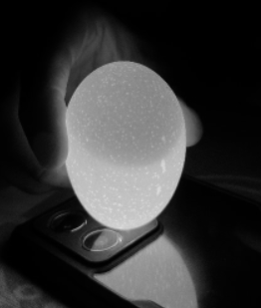

1) Harris Corner Detector:

Approach: Identifies corners in an image based on variations in intensity.

Explanation: Harris Corner Detector calculates the change in intensity for a displacement of (u, v) in all directions. By using the eigenvalues of a covariance matrix constructed from these intensity changes, corners are identified.

Input: Grayscale image.

Output: Image with marked corners.

Functionality: Highlights regions in the image where significant intensity changes occur in all directions, indicative of corners.

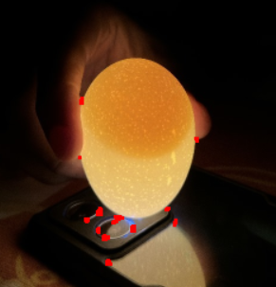

2) Difference of Gaussians (DoG) Detector:

Approach: Detects key points by computing the difference between two blurred versions of an image.

Explanation: It involves convolving the image with two different Gaussian filters and then taking the difference of these blurred images. This process highlights regions with significant intensity changes.

Input: Grayscale image.

Output: Image highlighting key points.

Functionality: Identifies regions with significant changes in intensity, often corresponding to key points such as edges and corners.

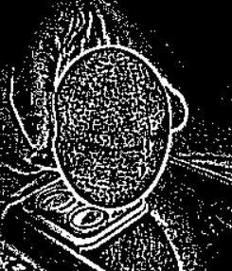

3) MSER Detector:

Approach: Detects regions of maximally stable extremal regions.

Explanation: MSER detects regions that remain stable over varying thresholds of intensity. These regions are typically blob-like structures.

Input: Grayscale image.

Output: Image with detected regions highlighted.

Functionality: Identifies stable regions in the image, robust to changes in illumination and noise.

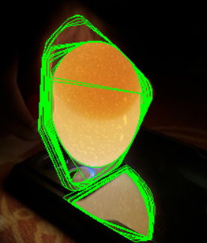

4) Shi-Tomasi Corner Detection:

Approach: An improvement over the Harris Corner Detector, using the minimum eigenvalue instead of the harmonic mean of eigenvalues.

Explanation: It selects corners based on a scoring function that considers both the minimum eigenvalue of the autocorrelation matrix and the distance between neighboring corners.

Input: Grayscale image.

Output: Image with detected corners marked.

Functionality: Detects corners based on local variations in intensity, more efficiently than the Harris Corner Detector.

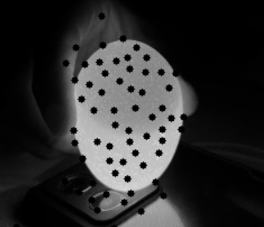

5) SIFT Detector:

Approach: Identifies key points based on scale-space extrema in the Difference of Gaussians pyramid.

Explanation: SIFT detects stable key points across different scales and rotations by constructing a scale-space representation of the image and identifying extremal points in this space.

Input: Grayscale image.

Output: Image with detected key points.

Functionality: Locates distinctive features in the image invariant to scale, rotation, and illumination changes.

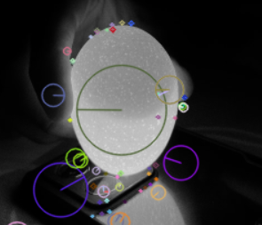

6) FAST Detector:

Approach: Uses a high-speed corner detection algorithm.

Explanation: FAST identifies corners by comparing the intensity of pixels in a circular pattern around a central pixel. It is a high-speed algorithm designed for real-time applications.

Input: Grayscale image.

Output: Image with detected corners.

Functionality: Quickly identifies corners in the image, suitable for real-time applications.

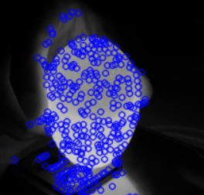

7) ORB Detector:

Approach: Combines aspects of FAST key point detector and BRIEF descriptor.

Explanation: ORB detects key points using FAST and computes descriptors using BRIEF. It's efficient and offers good performance.

Input: Grayscale image.

Output: Image with detected key points.

Functionality: Provides a fast and efficient method for key point detection and description.

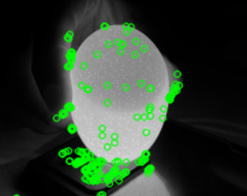

8) BRISK Detector:

Approach: Uses a scale-space FAST detector combined with a modified version of the binary robust independent elementary features (BRIEF) descriptor.

Explanation: BRISK detects keypoints in scale-space using FAST and generates descriptors using a modified version of BRIEF, which is more robust to scale and rotation changes.

Input: Grayscale image.

Output: Image with detected keypoints.

Functionality: Provides a robust and efficient method for detecting keypoints invariant to scale and rotation changes.

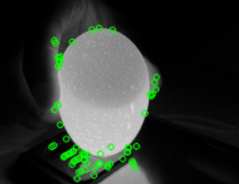

9) KAZE Detector:

Approach: Detects keypoints using nonlinear scale space.

Explanation: KAZE detects keypoints by analyzing nonlinear scale space representations of the image. It's designed to be more robust to nonlinear image transformations.

Input: Grayscale image.

Output: Image with detected keypoints.

Functionality: Provides robust keypoint detection, particularly in images with nonlinear transformations.

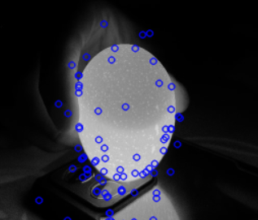

10) AKAZE Detector:

Approach: An improvement over KAZE, with additional descriptors for improved matching.

Explanation: AKAZE enhances KAZE by introducing additional descriptors that improve the matching process, particularly in challenging conditions.

Input: Grayscale image.

Output: Image with detected keypoints.

Functionality: Provides robust keypoint detection and improved matching performance, particularly in challenging conditions.

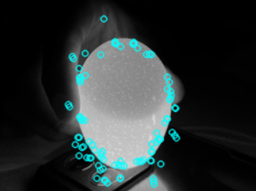

**Feature Matching Algorithms:**

1) Brute-Force Matcher:

Approach: Matches features by comparing every feature in the first set to every feature in the second set.

Explanation: It computes the distance between every pair of descriptors and matches those with the smallest distance.

Input: Descriptors of features from two images.

Output: Matches between features.

Functionality: Provides a simple but exhaustive method for feature matching.

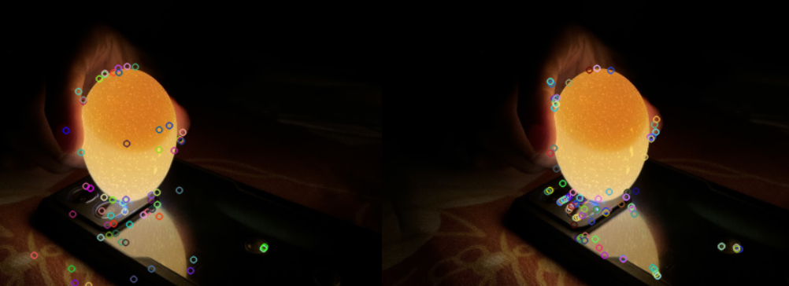

2) FLANN Matcher:

Approach: Utilizes the FLANN (Fast Library for Approximate Nearest Neighbors) algorithm for efficient matching.

Explanation: FLANN Matcher approximates the nearest neighbors using efficient data structures, improving matching speed.

Input: Descriptors of features from two images.

Output: Matches between features.

Functionality: Provides faster feature matching compared to brute-force methods, suitable for large datasets.

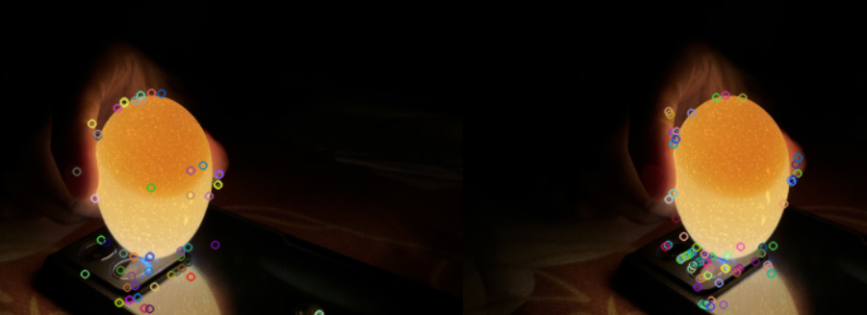

3) Brute-Force Matcher with Cross-Checking:

Approach: Matches features using a brute-force approach with cross-checking.

Explanation: It matches features from both images, but then checks if the match is mutual (i.e., a feature from the first image matches a feature from the second image and vice versa).

Input: Descriptors of features from two images.

Output: Matches between features.

Functionality: Reduces false positives by ensuring mutual matches between features from both images.

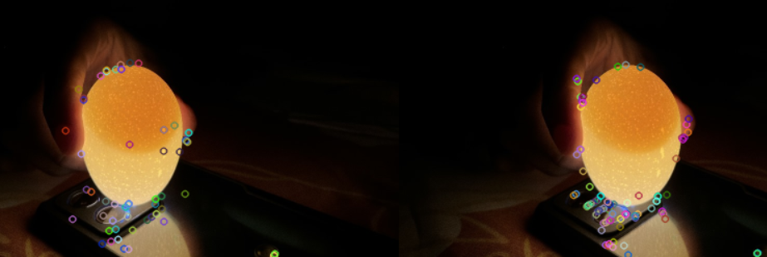

4) FLANN-Based Matcher:

Approach: Similar to FLANN Matcher but with more control over parameters.

Explanation: FLANN-Based Matcher utilizes FLANN but provides more control over parameters such as the algorithm used and the number of trees.

Input: Descriptors of features from two images.

Output: Matches between features.

Functionality: Offers improved performance and flexibility compared to the basic FLANN Matcher.

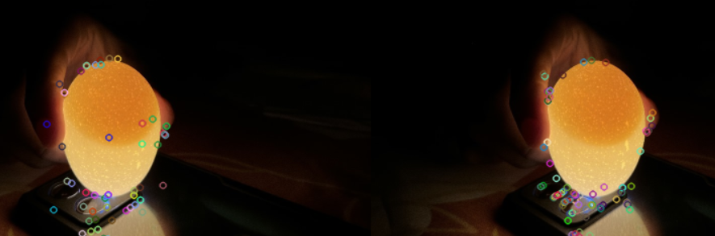

5) K-Nearest Neighbors (KNN) Matcher:

Approach: Matches features by comparing each feature in one set to the k-nearest neighbors in the other set.

Explanation: It finds the k-nearest neighbors of each feature in one set within the other set and considers matches with the smallest distance as potential matches.

Input: Descriptors of features from two images.

Output: Matches between features.

Functionality: Provides more flexibility in matching by considering multiple potential matches for each feature.

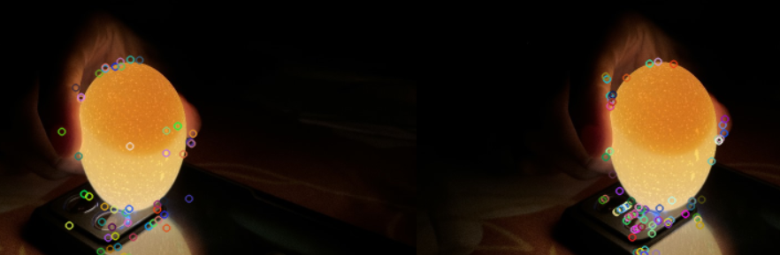

6) Radius Matcher:

Approach: Matches features within a certain radius of each other.

Explanation: It finds matches between features from both images where the distance between their descriptors is within a specified radius.

Input: Descriptors of features from two images.

Output: Matches between features.

Functionality: Allows for matching features that are within a specified distance of each other, useful for cases where the exact match is not necessary.

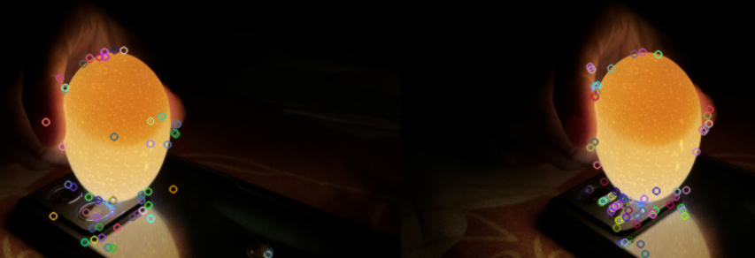

7) Ratio Matcher:

Approach: Matches features by comparing the ratio of distances between the best and second-best matches.

Explanation: It considers a match valid if the distance to the best match is significantly smaller than the distance to the second-best match.

Input: Descriptors of features from two images.

Output: Matches between features.

Functionality: Reduces false positives by considering the ratio of distances, providing more robust matching.

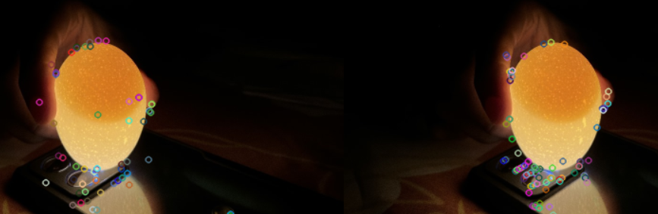

8) Cross-Check Matcher:

Approach: Matches features by checking for mutual matches between both images.

Explanation: It matches features from both images and then checks if the match is mutual, i.e., a feature from the first image matches a feature from the second image and vice versa.

Input: Descriptors of features from two images.

Output: Matches between features.

Functionality: Ensures mutual matches between features from both images, reducing false positives.

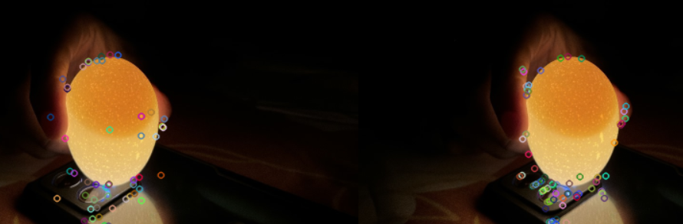

9) RANSAC Matcher:

Approach: Matches features using the Random Sample Consensus (RANSAC) algorithm to find the best transformation model.

Explanation: It uses RANSAC to estimate the transformation model (e.g., affine or perspective) between the matched features and removes outliers.

Input: Descriptors of features from two images, keypoints from both images, and a mask to indicate inliers.

Output: Inliers indicating valid matches.

Functionality: Robustly estimates the transformation model between images, particularly in the presence of outliers or mismatches.

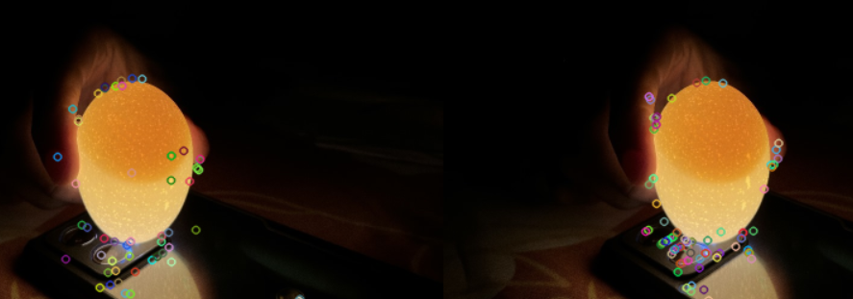

10) Brute-Force Cross-Check Matcher:

Approach: Matches features by ensuring mutual matching between two sets of descriptors using the brute-force method.

Explanation: This algorithm matches descriptors from two images in both directions and retains only the matches that are mutual.

Input: Descriptors of features from two images.

Output: A list of good matches that passed the mutual matching check.

Functionality: Ensures robust feature matching by performing bidirectional matching and retaining only mutually agreed-upon matches. This reduces false positives and enhances matching accuracy.

